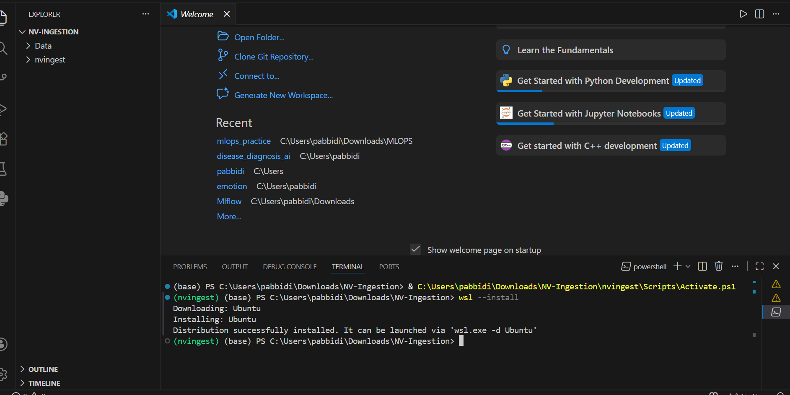

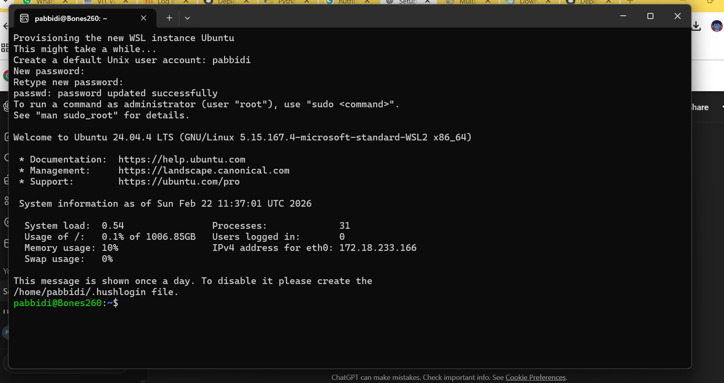

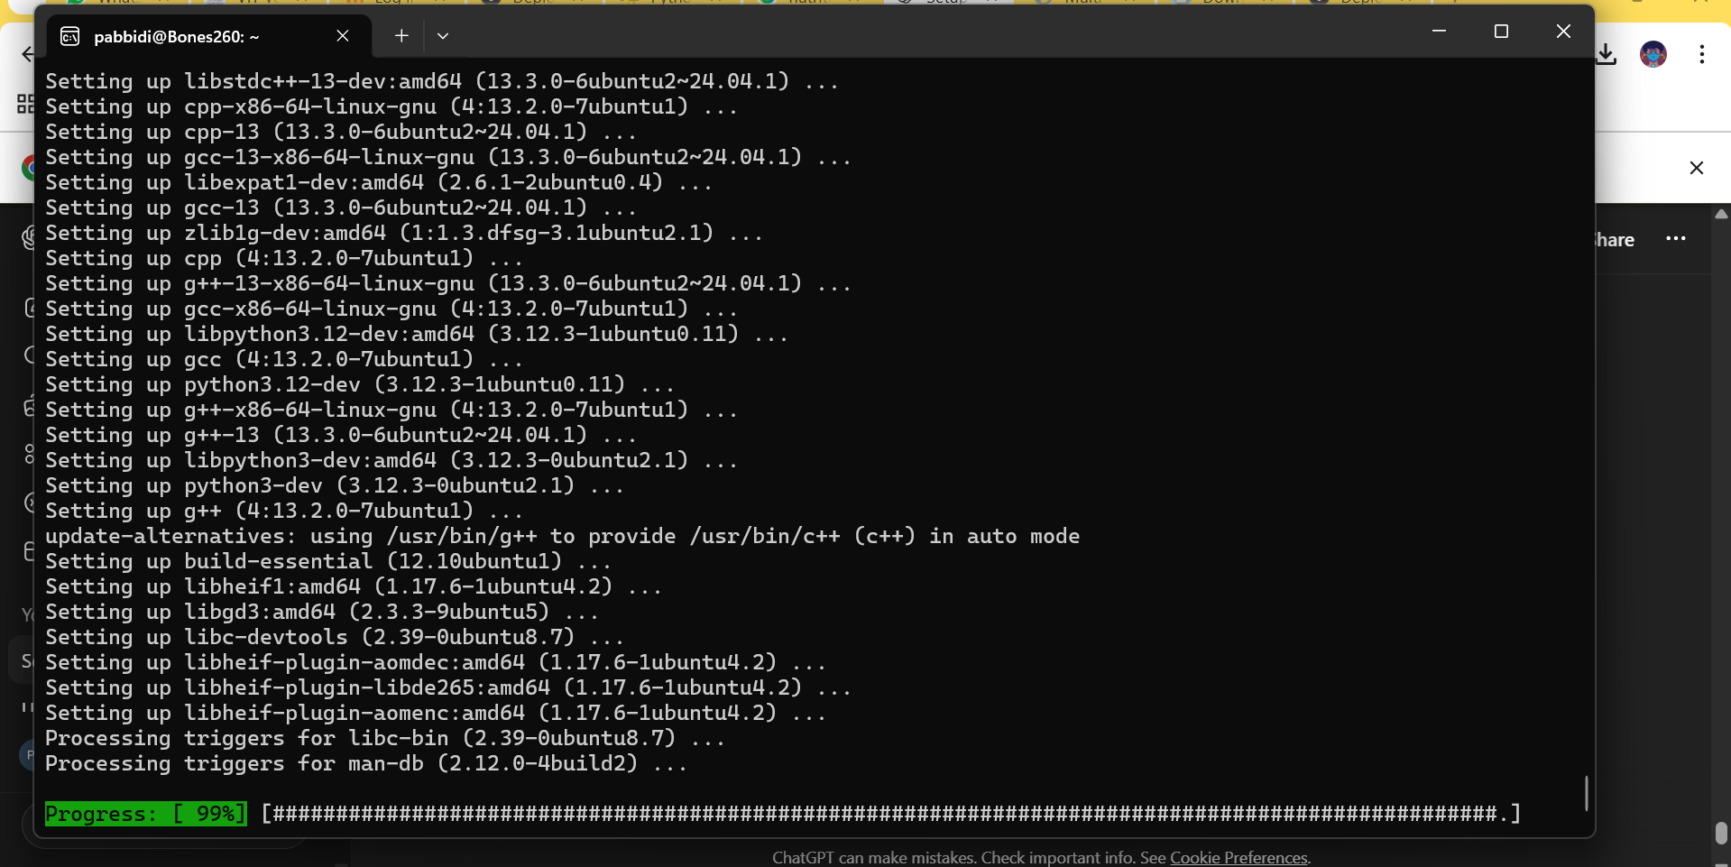
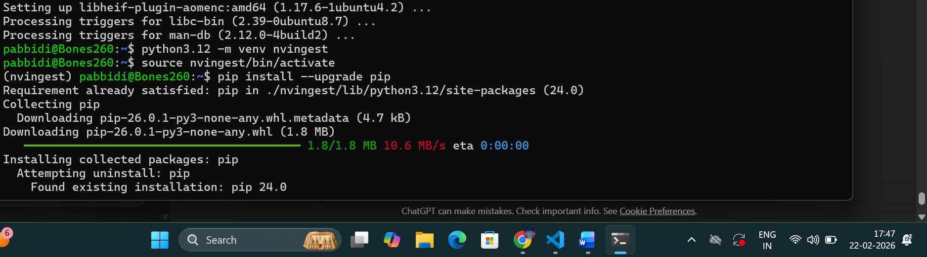
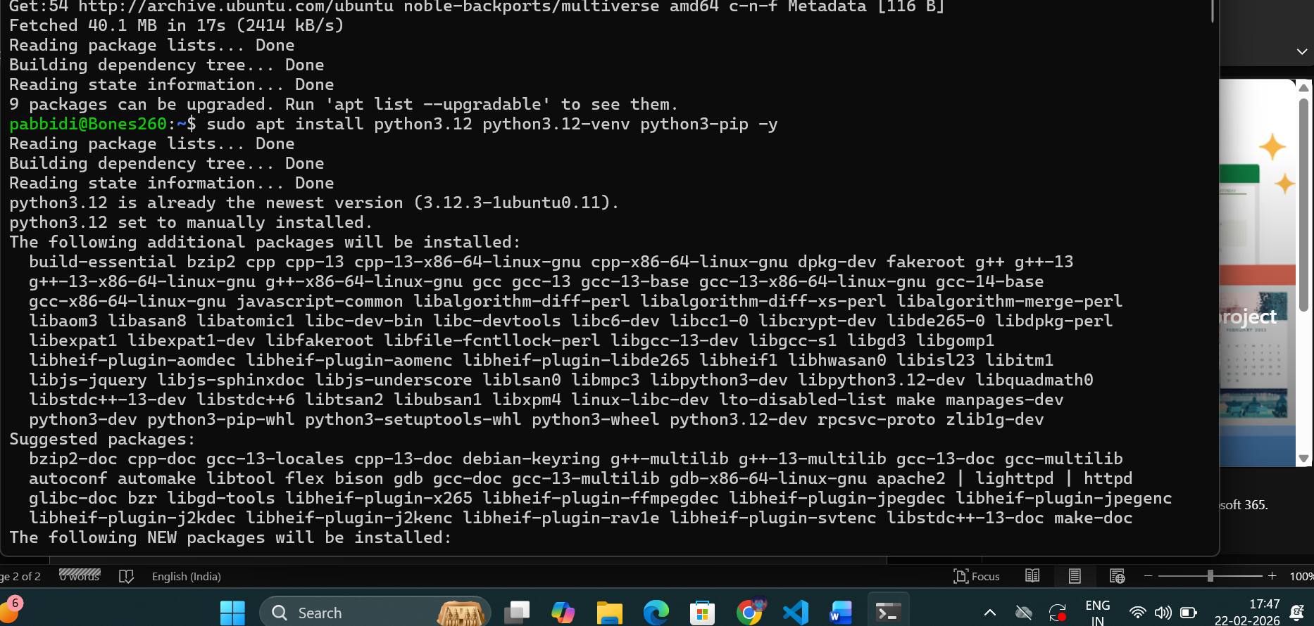
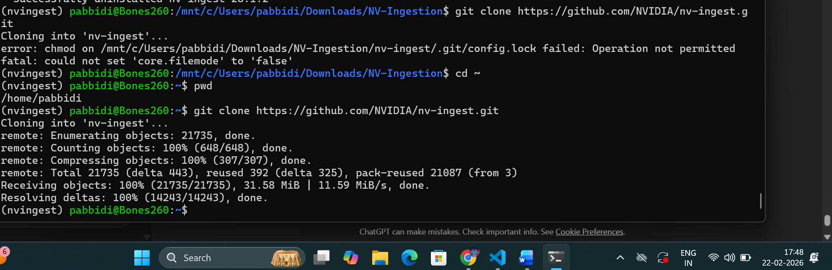
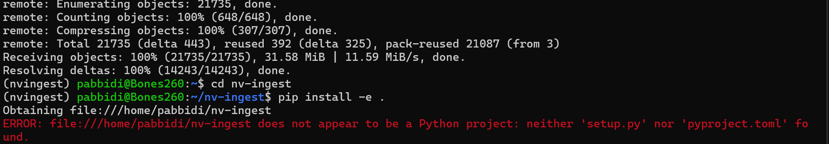
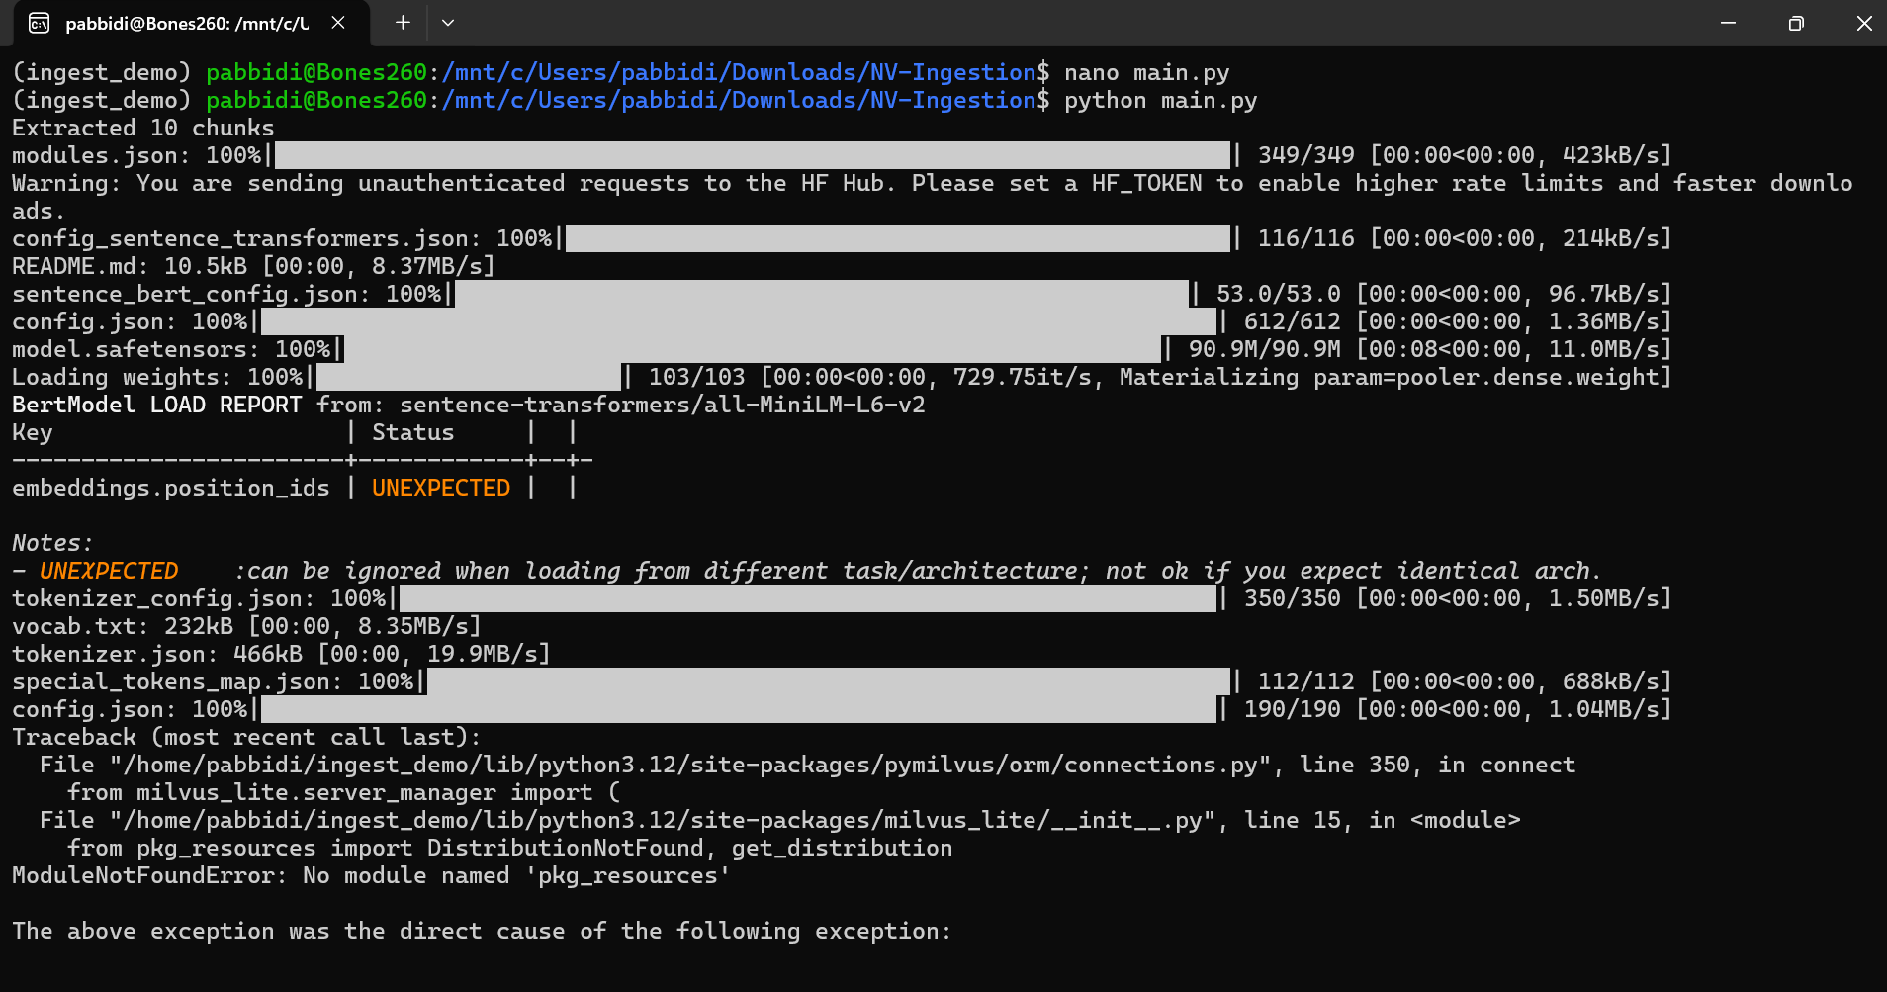
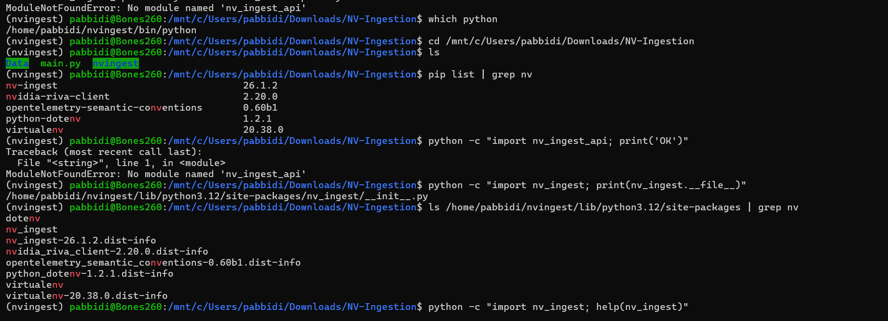

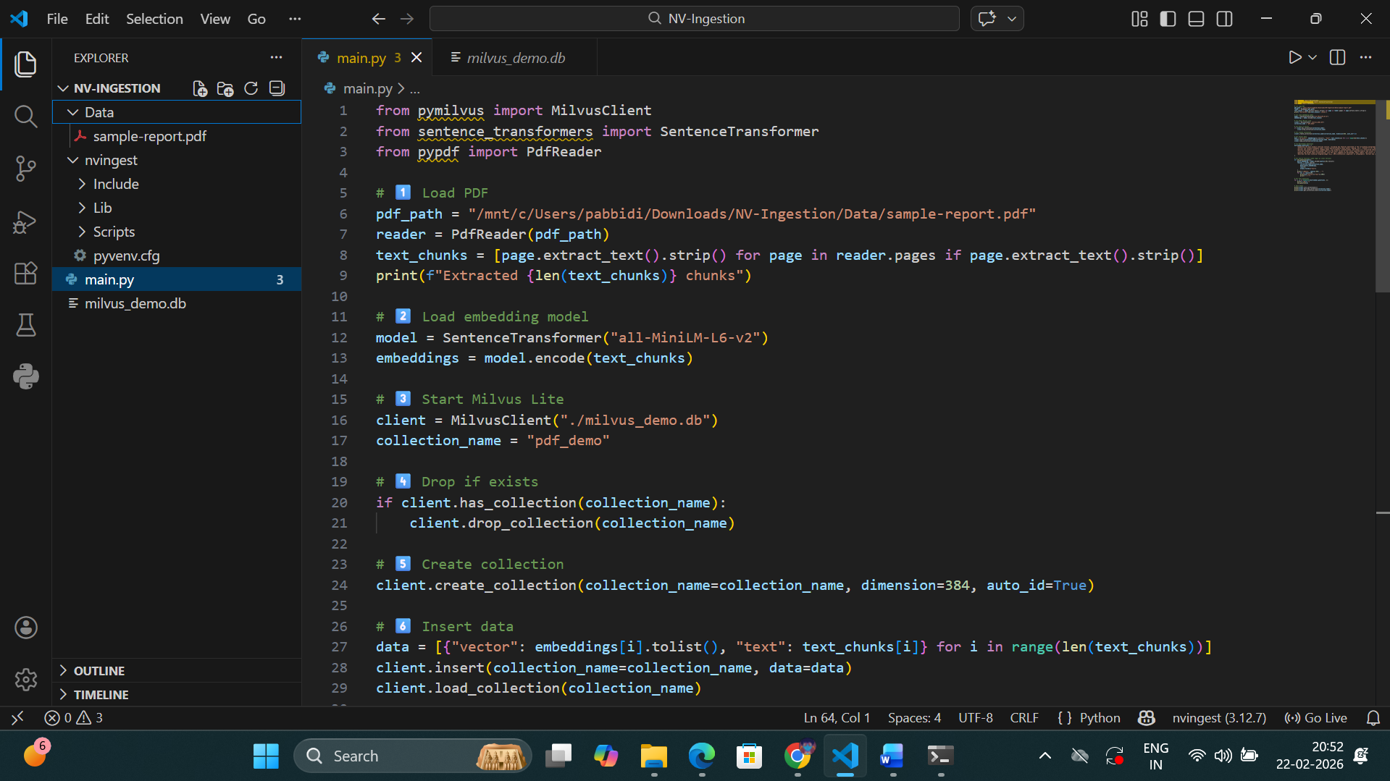
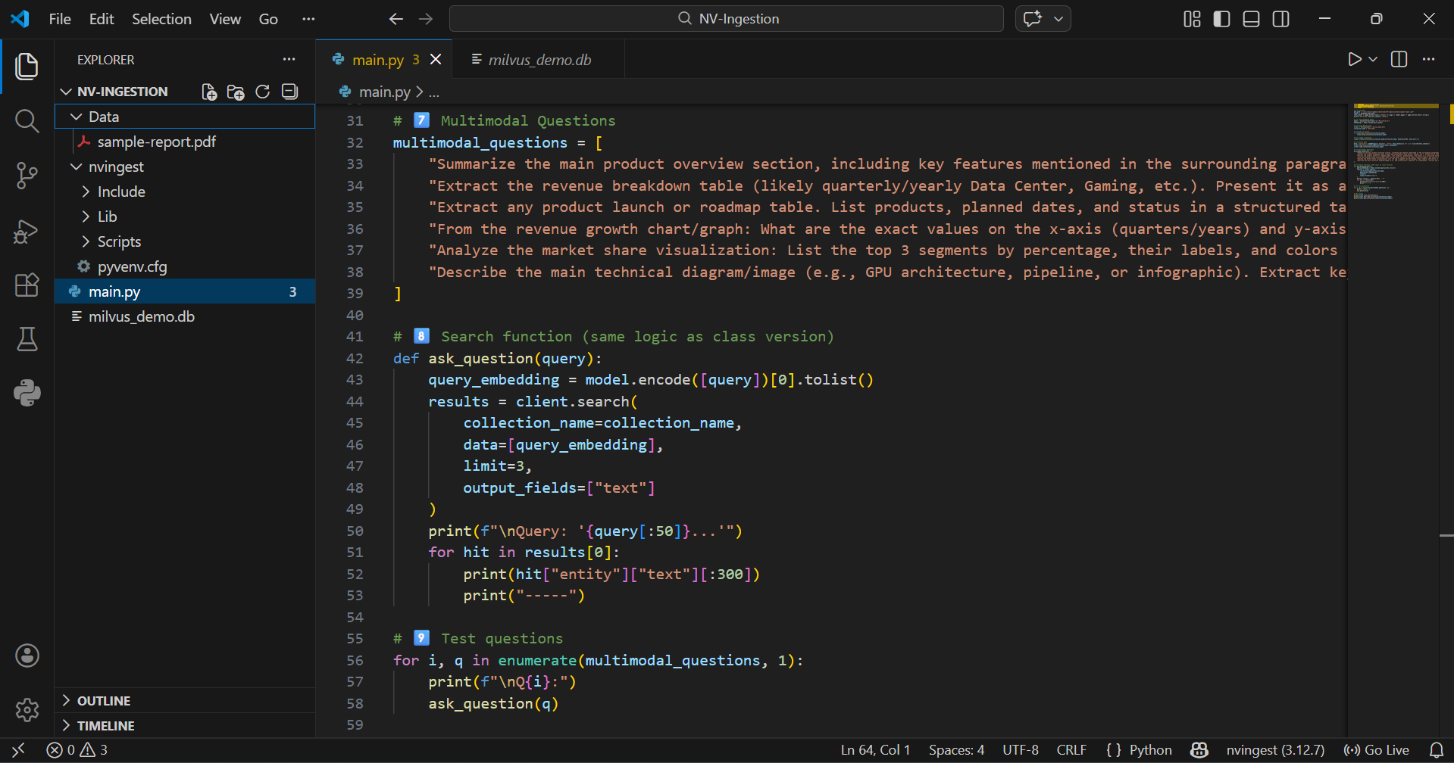
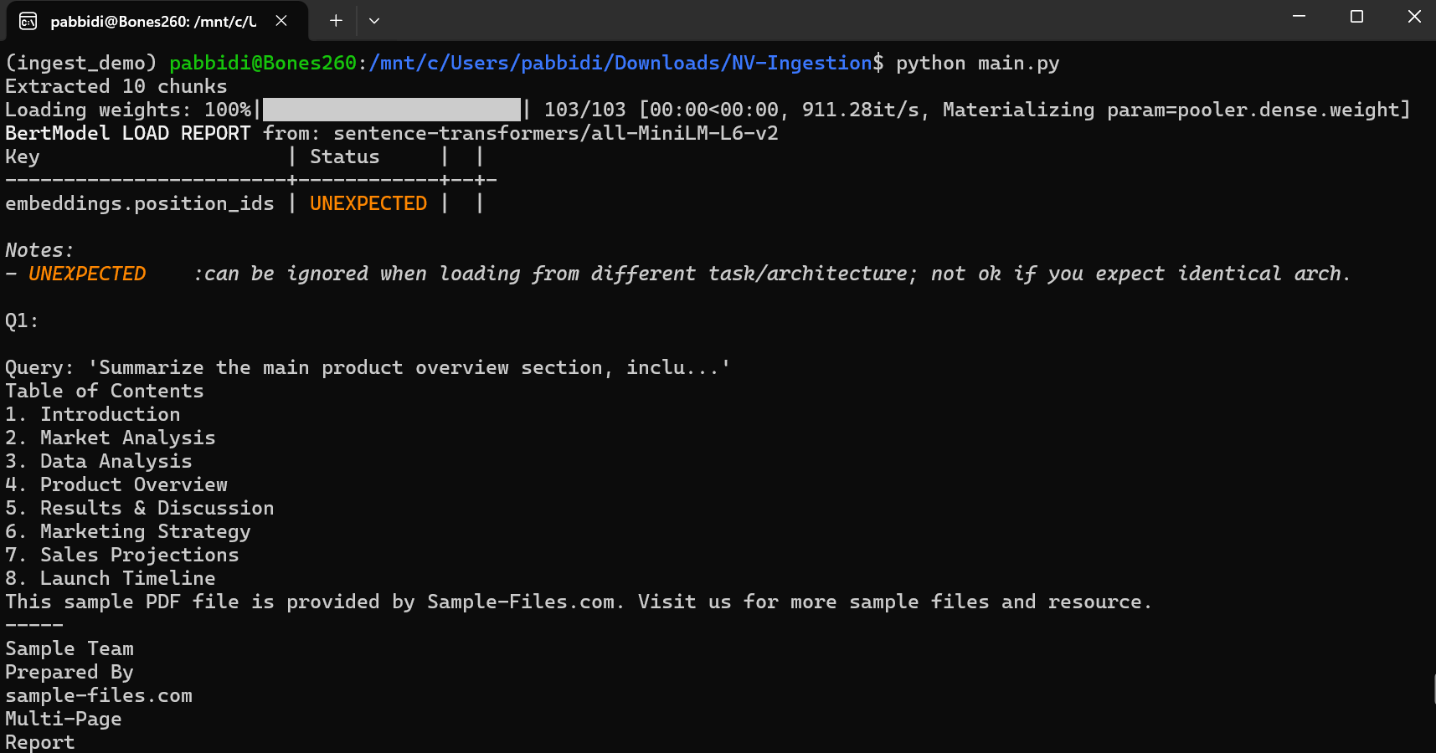
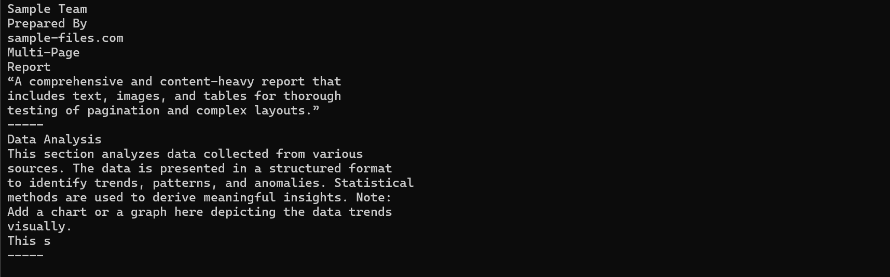
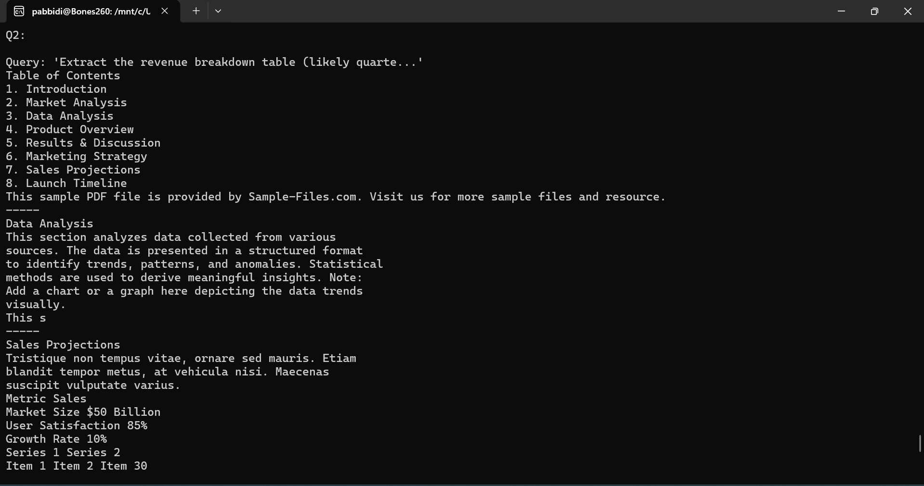
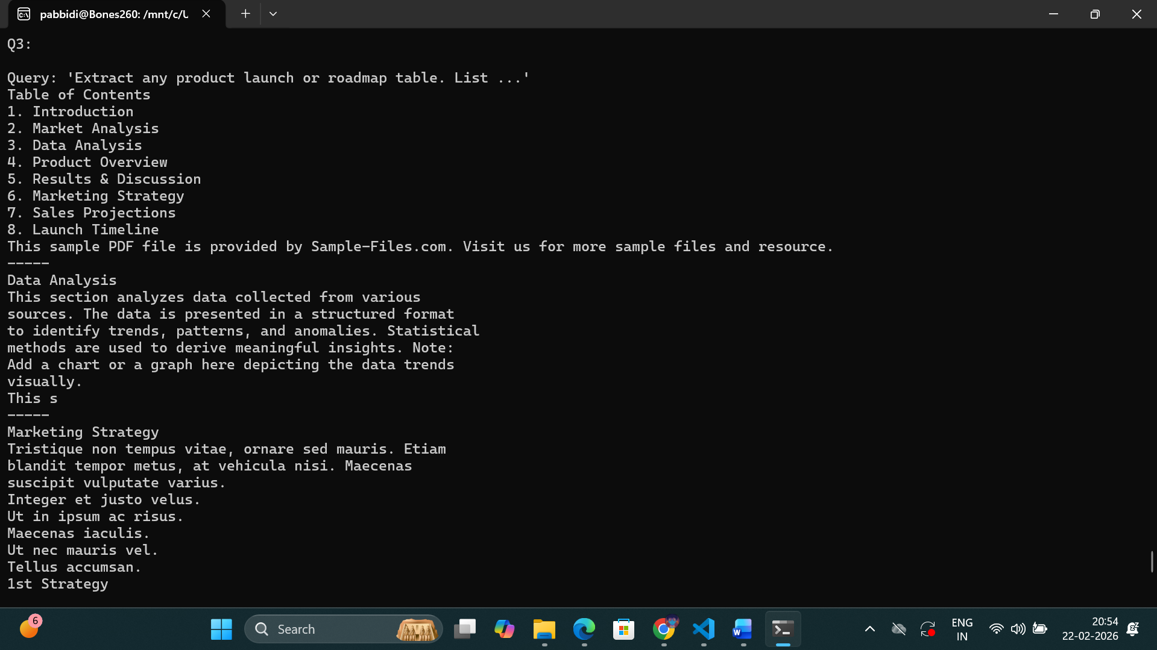
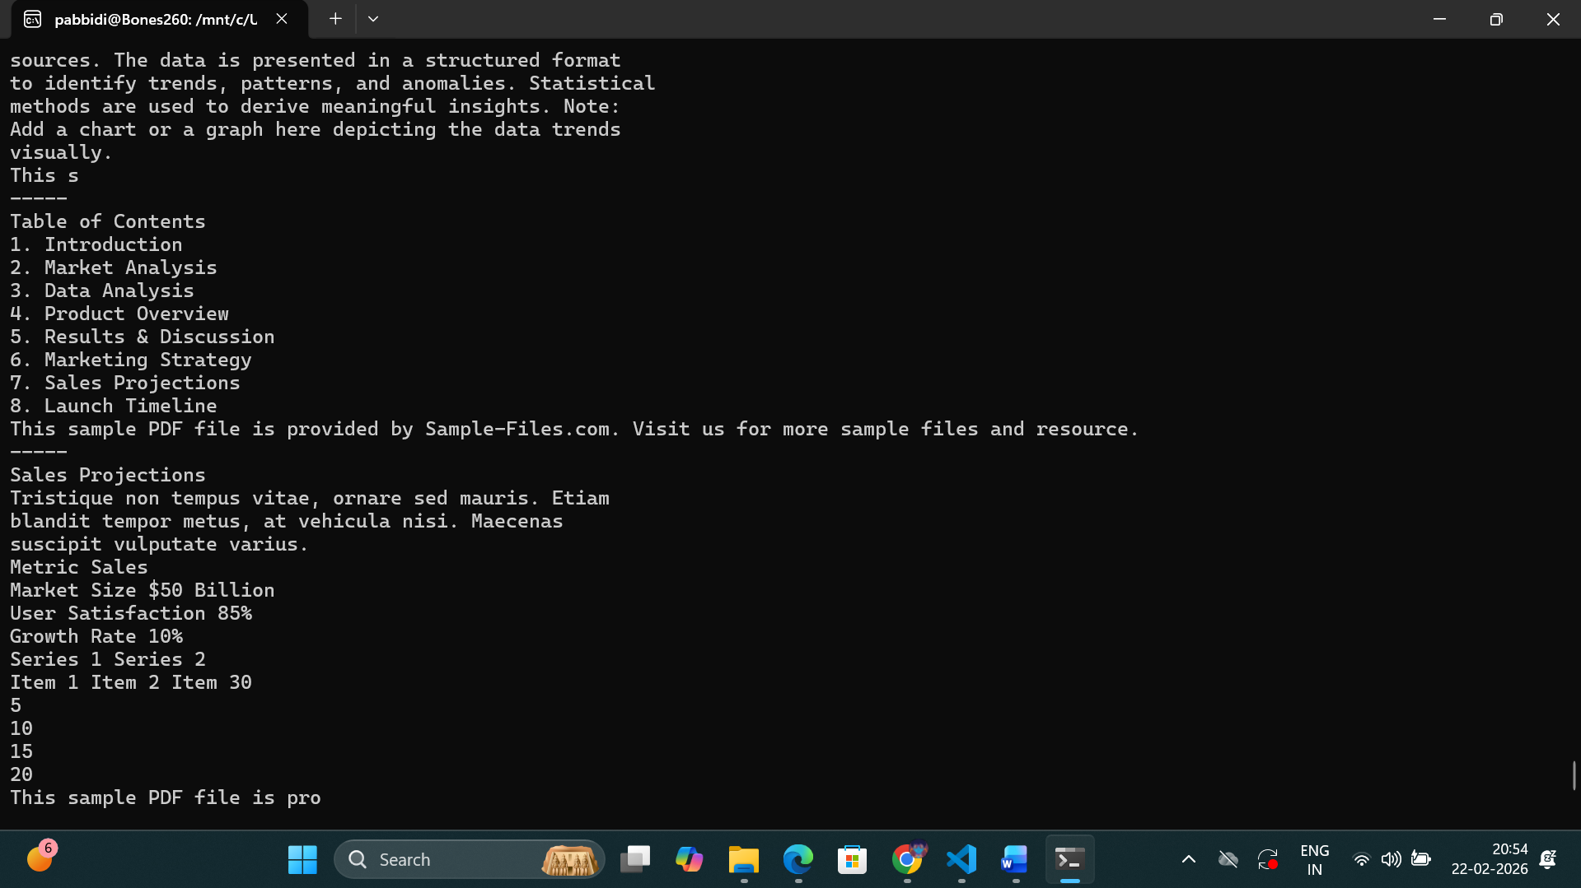

Component | Purpose
API service | Receives ingestion requests
Worker service | Processes files into embeddings
Message queue (Redis/RabbitMQ) | Orchestrates jobs between services
Vector DB (Milvus server) | Stores embeddings and metadata
Optional GPU containers | Speed up embedding computation
Backend configuration | Networking, volumes, environment variables
Key point: The client script assumes all of these services are already running.

2️⃣ What happens when we try to run the script directly
On your laptop, if you run:
python nv_ingest_script.py
Without the backend services:
- The client cannot connect to API or worker services → connection errors
- If Milvus server is missing or wrong version → add_field / create_index errors
- Any expected environment variable or Docker network is missing → service fails silently or crashes
In short: The script is not self-contained. It will never work standalone.

3️⃣ Why Docker + NV-Ingest is tricky
Even if you have Docker:
- Multi-container orchestration
NV-Ingest requires multiple containers:
  - API
  - Workers
  - Message queue
  - Milvus server
  - (Optional) GPU container
These need:
  - Correct network links
  - Proper volume mounts for files
  - Environment variables
On Windows + WSL, this often breaks because:
  - GPU support is limited in WSL Docker containers
  - File paths (/mnt/c/...) need correct mounting
  - Docker networking sometimes blocks container-to-container communication
- Version mismatches
  - NV-Ingest expects specific Python version (e.g., 3.10)
  - Milvus server version must match client API
  - Docker image tags must be compatible
If versions don’t match:
  - add_field errors (API changed)
  - create_index fails (new Milvus syntax)
  - index_params mismatch errors
- Resource and stability
  - Full NV-Ingest pipeline is heavy
  - Multiple containers + message queues + Milvus server → high CPU/RAM usage
  - Logs scattered across containers → harder to debug

Even if you “installed everything,” this error occurs because of how NVIDIA packages NV-Ingest:
- Pip package (nv-ingest) is incomplete
  - pip install nv-ingest only installs the minimal client library.
  - It does NOT include nv_ingest_api, which is part of the full source repo.
  - Some modules like ray_pipeline, pid_controller, pipeline_runners internally depend on nv_ingest_api.

“The official NVIDIA NV-Ingest pipeline requires multiple components running together: an API service, worker service, message queue (like Redis), and a full Milvus server.
I cloned the full NV-Ingest repo and tried to set up the environment, but the Python client depends on nv_ingest_api, which is not included in the pip-installed package — it must be installed from the source repo in the environment.
Additionally, even with the source installed, the pipeline requires all backend services running, proper networking, and correct container versions.
On my personal laptop, setting up these services with Docker + GPU + volume mounts caused version mismatches and runtime issues.
For example, Milvus Lite differs from the full Milvus server, and some API calls in the client failed (add_field, create_index).
Therefore, to achieve a working ingestion and retrieval setup locally, we used a simplified architecture with MiniLM embeddings and Milvus Lite. This allowed us to ingest PDFs and perform semantic search successfully without the full NV-Ingest microservices stack.”

MilvusClient("./milvus_demo.db")
- This is Milvus Lite (embedded mode).
- It stores vectors locally in a single file (milvus_demo.db).
- No network, no server, no ports.
- Everything runs inside your Python process.

Why we use WSL here:
- Milvus Lite and some Python libraries work more smoothly in Linux.
- Some NVIDIA dependencies, pip packages, and system libraries have better compatibility in Linux than Windows.
- WSL bridges Windows UI + Linux environment.

Your code already covers Create, Read, Search:
Operation | How it’s done
Create collection | client.create_collection(collection_name=..., dimension=384, auto_id=True)
Insert data | client.insert(collection_name=..., data=...)
Load collection (for search) | client.load_collection(collection_name)
Read / Search | client.search(collection_name=..., data=[query_embedding], limit=3)
Describe collection | client.describe_collection(collection_name)
Stats | client.get_collection_stats(collection_name)
Drop collection | client.drop_collection(collection_name)
✅ Optional CRUD additions:
- Update vector/text → Lite does not have in-place update; you typically:
  - Delete old entity
  - Insert new entity
- Delete entity → In Lite, you can delete by ID:

How your code maps to CRUD
Let’s walk through your code:
Step 1: Create
client.create_collection(collection_name=collection_name, dimension=384, auto_id=True)
- Creates a collection pdf_demo in Milvus Lite.
- This is the Create part of CRUD (collection-level).
data = [{"vector": embeddings[i].tolist(), "text": text_chunks[i]} for i in range(len(text_chunks))]
client.insert(collection_name=collection_name, data=data)
- Inserts vectors + text → Create at data-level.
- Each vector gets an auto-generated ID because auto_id=True.
✅ So Create = collection creation + insert

Step 2: Read / Search
query_embedding = model.encode([query])[0].tolist()
results = client.search(
collection_name=collection_name,
data=[query_embedding],
limit=3,
output_fields=["text"]
)
- Search vectors using embeddings → Read operation.
- Milvus compares query vector to stored vectors using L2 distance or cosine.
- Returns top N results with their associated text.
✅ So Read = search / retrieving stored data

Step 3: Delete / Drop
if client.has_collection(collection_name):
client.drop_collection(collection_name)
- Drops the whole collection and all vectors inside.
- This is Delete at collection level.
⚠ Note: You can also delete specific vectors by ID in Lite, like:
ids_to_delete = [1, 2, 3]
client.delete(collection_name, ids=ids_to_delete)
- This is Delete at vector level.

Step 4: Update (manual)
- Milvus Lite cannot upsert (update in-place).
- To “update” a vector:
  - Delete the old vector by ID
  - Insert the new vector (with updated content)
client.delete(collection_name, ids=[old_id])
client.insert(collection_name, data=[new_vector])

How HNSW works (step by step)
HNSW = Hierarchical Navigable Small World graph
- It’s a graph-based index:
  - Nodes = vectors
  - Edges = connections to nearby vectors
- Multi-level hierarchy:
  - Top layer → few vectors, fast approximate search
  - Lower layers → more vectors, finer search
Search steps in HNSW:
- Start at top layer (small graph)
- Move to closest neighbor to the query (greedy search)
- Descend layer by layer until reaching bottom layer (full detail)
- Return top-k nearest vectors

HNSW is a type of ANN index. Its search is ANN, but it uses graph traversal instead of cluster-based filtering.
- IVF / Cluster ANN:
Query → find nearest clusters → search vectors in those clusters → approximate nearest neighbor
- HNSW / Graph ANN:
Query → start at top-level graph → traverse closest nodes → descend layers → reach bottom → approximate nearest neighbor
- Both do not scan full dataset, so both are ANN, but HNSW uses a graph, IVF uses clusters.

